VISITING THE
DRAKES BAY
NATIONAL HISTORIC
LANDMARK SITES
A guide to the sites at the Point Reyes National Seashore associated with the Drakes Bay Historic and Archeological District National Historic Landmark, including Francis Drake (1579), Sebastião Rodrigues Soromenho (1595) and the Coast Miwok
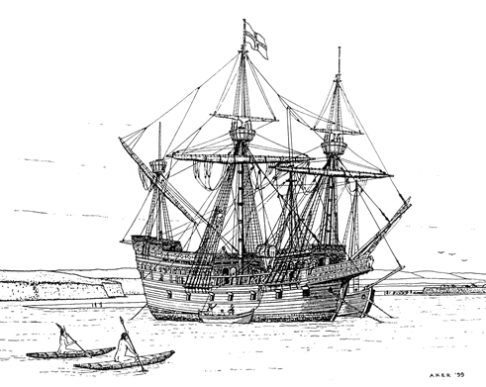

Copyright © Michael Von der Porten
2016
All Right Reserved

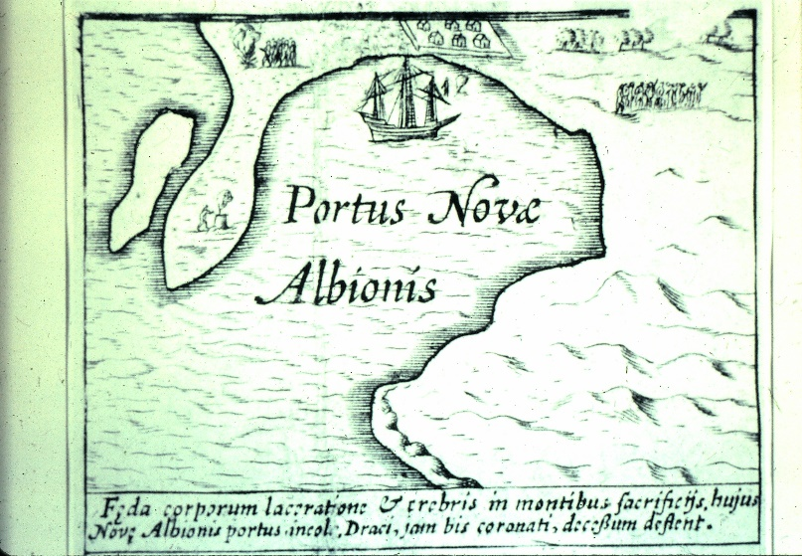
Updated 10/26/2016

Table of Contents
Contents
Welcome 5
Drake’s Beach Sites 6
The 400th Anniversary Marker from the Sir Francis Drake Commission (1979) 8
Drake’s Cove Hike 9
Safety 9
The Hike 11
Stop 1 11
Stop 2 12
Stop 3 13
Stop 4 13
Stop 5 14
Stop 6 15
375th Anniversary Monument from the Consul General of Great Britain (1954) 17
400th Anniversary Monument from the Drake Navigators Guild (1979) 18
Stop 7 19
The Sir Francis Drake Association of California Monument (1946) 20
Ken Patrick Visitor Center Exhibit 21
Courtyard Display 22
Plaque at the Lifeboat Station 23
The E Clampus Vitus Monument (1950) 23
Plaque at Limantour Beach Parking Lot 24
The Drakes Bay National Historic and Archaeological District Plaque 24
Sites at Bear Valley Visitor Center 25
Golden Hind Model 25
Visitor Center Exhibit 26
Park Dedication Plaque (1964) 26
Kule Loklo 27
Further Investigation 28

Welcome!
Your adventures will take you into one of the most important historic areas of the United States – even the world.
- This is where England first claimed what has become the United States, well before any east coast claims.
- This is where Francis Drake and his crew spent five weeks repairing his ship, the Golden Hind, resupplying, loading water and meeting with the Coast Miwok.
- This is the site of the first service of the Church of England in the future United States. It is here that the first readings were made from the Book of Common Prayer in the future United States.
- This is the site of the first shipwreck in California history.
- This is the location of the first Hispanic contact and African black contact in northern California.
- This where the first Portuguese person visited California.
- This is the location of the first Spanish visit to northern California.
- This is the site of the first Catholic observances in northern California.
And, so much more!
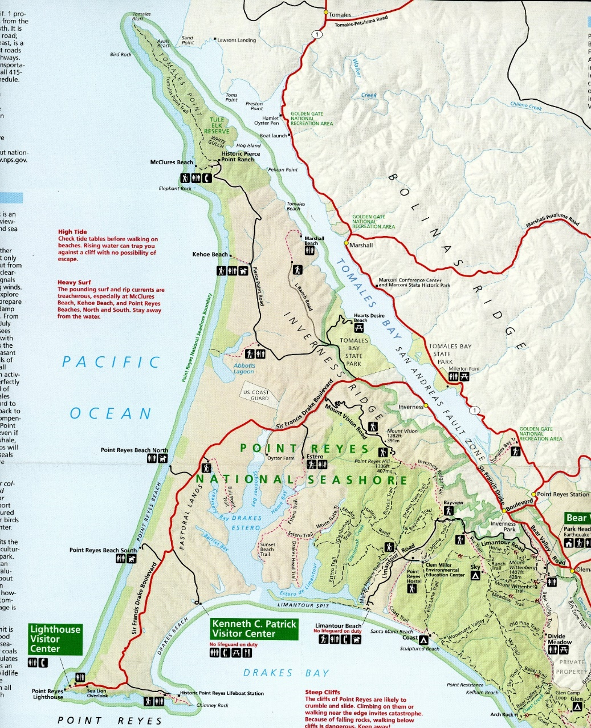
D
C
B
A
A

Drake’s Beach Sites
A
The Drake’s Beach sites include the 400th Anniversary marker from the Sir Francis Drake Commission, the 375th Anniversary marker from the Consul General of Great Britain, the 400th Anniversary marker from the Drake Navigators Guild and the 1946 marker from the Sir Francis Drake Association of California.
Visiting these sites allows the visitor to experience much of what was experienced in 1579 and 1595.
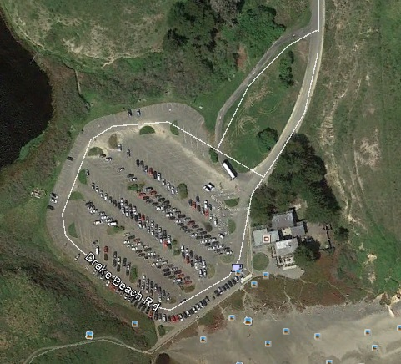
11
9
10
1
Image credit: GoogleEarth

The 400th Anniversary Marker from the Sir Francis Drake Commission (1979)
1
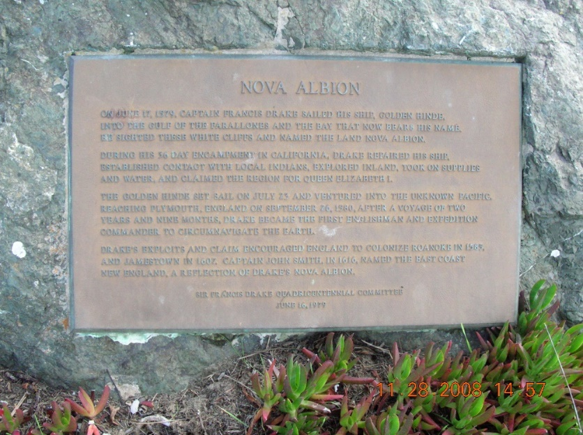
From the Drake’s Beach parking lot, look south toward the ocean. Here you’ll find the 400th Anniversary marker from the Sir Francis Drake Commission. This group held numerous commemorative events including a ceremony, cannon firing, speeches and the plaque unveiling.
This hike travels 1-1/4 miles, first east on Drake’s Beach and then north to Drake’s Cove and the Drake monuments.

Drake’s Cove Hike
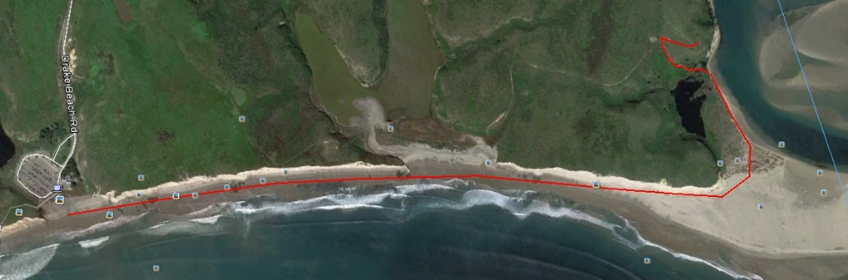
8
7
6
5
4
3
2
Image credit: GoogleEarth
To visit the next two monuments, you’ll need to take a hike. Allow three hours. Please read and follow the safety notes, below.
The hike is primarily on hard sand.
There is an optional extension ¼ mile in each direction that goes up 170 feet up a hillside.

Safety
The conditions here change by the month and by the hour. A good, large beach is needed because rocks make travel difficult and even risky if they must be crossed.
During the winter, storms wash away much of the sand. Springtime conditions return the sand. Thus, this hike is best considered in the late spring, during the summer and in the early fall.
Daily tides increase and decrease the amount of beach available for walking. Therefore, it is best to seek the hours leading into and out of a high tide. Online and paper copy tide tables are readily available: be sure to consult them or check with local officials about the tides.
Always watch the ocean. Never turn your back on the ocean. This part of the Pacific is known to be deadly. The combinations of smaller and larger waves can unpredictably produce a big wave. It will knock you off your feet and drag you into the surf. You will likely not survive.
This is called an “undertow” and is extremely strong. Your only chance to escape is to swim parallel to the beach and then try to work your way ashore.
Watch your children at all times and do not allow them to play in the surf.
No dogs are allowed at Drake’s Beach. At other beaches along the northern California coast, pet dogs have been dragged into the water. Owners have tried to rescue their dogs only to drown themselves.
Stay away from the cliffs – both at the top and the bottom. The entire Point Reyes area is made of unstable rock conglomerates, broken up by millennia of geological forces. These cliffs break apart regularly with no warning.

The Hike
From Drake’s Beach parking lot, head toward the Pacific Ocean. You are walking south. Yes, directions are confusing, so bring and use a map.
Turn left. You will be headed due east!
2
Stop 1 – halfway along the first big cliff
As part of a “cold war” with Spain, Francis Drake led a group of five ships out of Plymouth Harbor, England in late 1578. After crossing the Atlantic Ocean, two supply ships were broken up. Heading through the Strait of Magellan, one ship was lost, one ship turned back and the Pelican, renamed the Golden Hind, successfully entered the Pacific Ocean.
Raiding Spanish ports and ships along the coast of South America, but treating captives well, Drake acquired 26 tons of silver and other treasure.
Seeking a route home, Drake sailed north to travel across the top of North America through the legendary (but non-existent) Strait of Anián. Not finding the passage, Drake headed south seeking a harbor.
After 400 miles, in June 1579, Drake rounded Point Reyes to find this big bay and these white cliffs.
Can you see why these cliffs reminded Drake of the White Cliffs of Dover?
Stop 2 – at the rocks at the far end of the first big cliff
3
The Manila Galleon trade was the trans-Pacific commerce that operated from 1565 to 1815. A few ships each year sailed west from Acapulco, Mexico loaded with silver, mostly from the Bolivian mines at Potosi.
In Manila, the Philippines, Chinese goods had been stocked for the trade. Silk, wax, spices and porcelains were loaded for the return trip. The wax was for churches in Mexico. The other items were ultimately destined for the luxury markets in Spain.
Instead of the two months the westward voyage took, the eastbound voyage required a detour north to catch the trade winds and then a trip south to Acapulco. This could take six months, during which the dreaded disease scurvy could take a terrible toll.
Seeking to find an intermediate harbor for the eastbound Manila Galleons, the Spanish ordered captain Sebastião Rodrigues Soromenho (“Sebastián Rodríguez Cermeño” in Spanish) to land at a northerly point on the North American coast, put together a pre-built small boat and explore the coast on his way south.
Soromenho sailed into Drakes Bay in November 1595 just off this point. What are weather conditions like here in November?
Stop 3 – at the break between the first and second cliffs
4
Note the rock dyke coming from the cliff toward the sea. This is your barrier to your return. If there is not much beach visible and if the tide is coming in, it may be smart to turn around here.
Drake sailed into the bay. He had a small boat with him. The small boat explored the entrance to what we now call Drakes Estero, just ahead. Dropping a ½ pound sounding lead (piece of lead on a string), they found the entrance more than deep enough for the Golden Hind’s 13 foot draft.
Drake soon had his ship within the harbor.
5
Stop 4 – halfway along the second big cliff
Soromenho and his men were on Limantour Spit, just ahead across the entrance to Drakes Estero. There, they were building the small boat to explore the coast to the south.
In late November, 1595, a bad storm blew in from the south. (Most storms here come from the northwest, so the headland of the Point Reyes provides great protection).
The San Agustin dragged anchor. The ship broke apart while the crew helplessly watched from the shore. The small number of men aboard the ship perished.
Soromenho’s crew used wreckage from the San Agustin as it washed ashore to build up their small craft. The 85 men sailed their precarious craft south – arriving safely in Mexico!
Stop 5 – at the far end (east end) of the second big cliff
6
Across the Estero, Soromenho and his men certainly held Catholic observances, the first in northern California.
Soromenho, a Portuguese pilot was the first certain Portuguese person in what has become California.
Soromenho‘s crew was largely made of Spanish and Mexican sailors. These were the first certain Spanish and Mexican people in northern California.
But, Drake had a pilot aboard who helped him navigate the North Pacific. His name is reported as N. de Morera or N. de Morena. This is a well-known Spanish and Portuguese surname. So, was de Morera the first Spanish or the first Portuguese person in this area? Regardless, it happened here and is part of the National Historic Landmark. (de Morera did not leave with Drake and instead spent four years walking back to Mexico!)
It was common for new sailors to be picked up by the Manila Galleons in the Philippines. Almost certainly, Filipino sailors were aboard the San Agustin and, likely, Chinese sailors were aboard. Those would be the first people from the Philippines and China to reach California.
7
Stop 6 – at the Drake monuments
This area was a nice harbor in 1579. The Cove was diked off by a rancher for a fresh-water pond in the 1940s.
This allows you to stand where the Golden Hind was careened. Careening is the process of tipping a ship on one side, then the other, to clean and repair its hull.
Drake had to careen his ship several times during his voyage, so this was a process Drake and his crew knew. What he needed was a protected harbor which Drake’s Cove provided.
Here, Drake built a small stone fort. He watched as the Coast Miwok formed at the top of the hill, then broke ranks and came down toward the English.
With a cargo of silver, being 1/3 of the way around the world and with hundreds of unknown people descending, what would you do? Drake chose to let the Coast Miwok in.
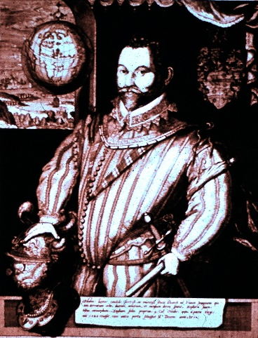

375th Anniversary Monument from the Consul General of Great Britain (1954)
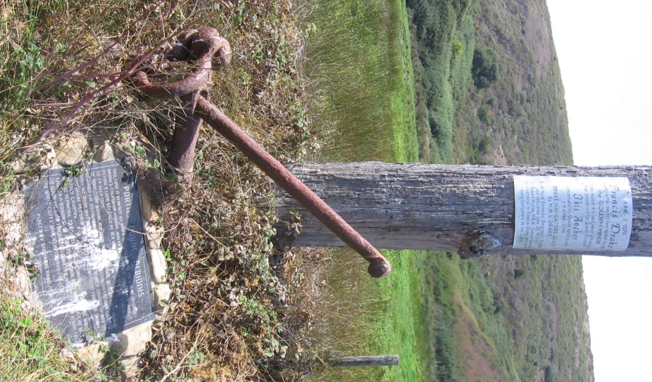
Anchor presented by H.M.S. Drake, Royal Barracks, Devonport, England and dedicated by Robert Hadow, H.B.M., Consul General. (Yes, a land-based barracks can be called “Her Majesty’s Ship” [H.M.S.] in England.)

400th Anniversary Monument from the Drake Navigators Guild (1979)
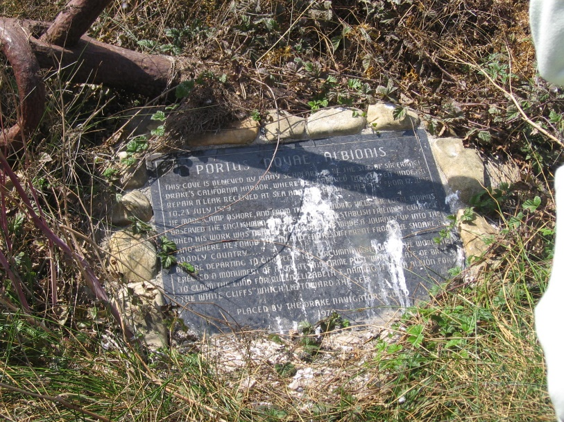
- - - - -
If you do not wish to extend your hike, return back along the beach the way you came in. (Do, though, read about Stop 7.)
If you wish to visit the bluff overlook to the Drake landing site, proceed a short distance inland and follow the rough trail (old road) up the hillside and then take the turn to the right ¾ of the way up the hill. It’s a bit rough and there is poison oak along the path, so tread carefully!
- - - - -
Stop 7 – at the top of the bluff
8
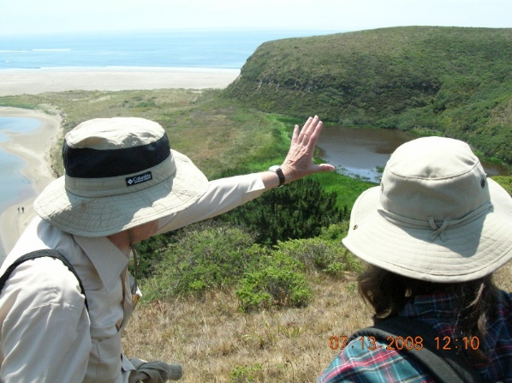
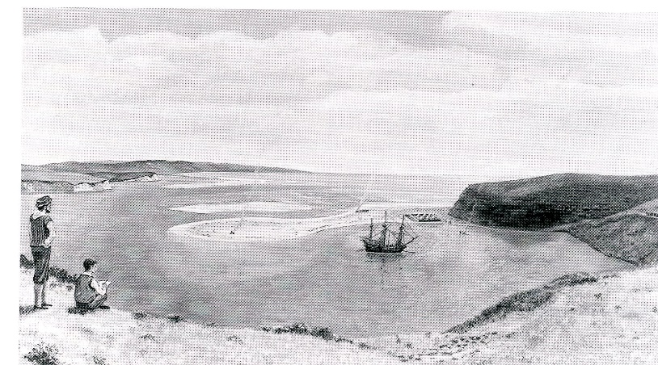
From this position above Drake’s Cove, you can see what Drake’s men saw and drew. A drawing of this scene is included in an important map called the “Hondius Broadside.” (A “broadside” is a single-sided, large printed sheet.) This drawing establishes the exact location of Drake’s stay.
It is here that Drake careened his ship. (“Careening” is the tipping of the ship on one side and then the other to clean and repair the hull.)

The Sir Francis Drake Association of California Monument (1946)
9
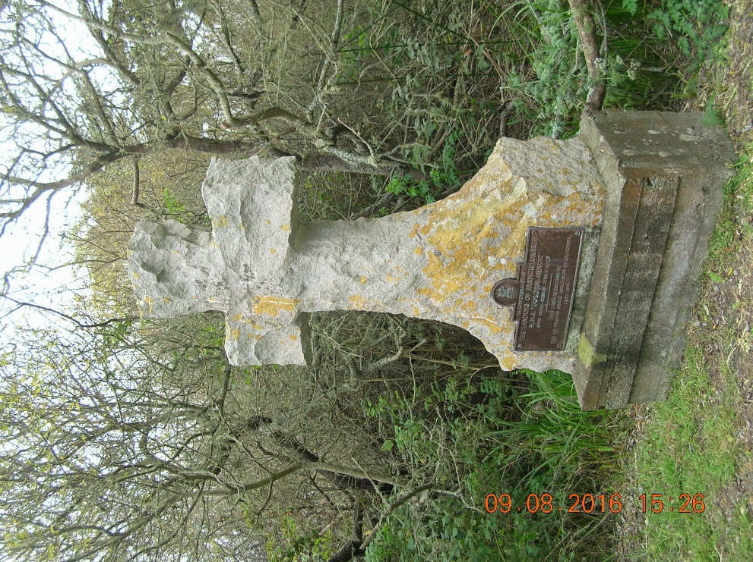
8
This monument is across the parking lot from the Ken Patrick Visitor Center.
This monument has a cross design as a reminder of the key role of Drakes Bay in the history of the Church of England, known in America as the Anglican Church or the Episcopal Church. The first service conducted from the Book of Common Prayer, the book of services for the Church of England, was held at Drakes Bay in 1579.

Ken Patrick Visitor Center Exhibit
10
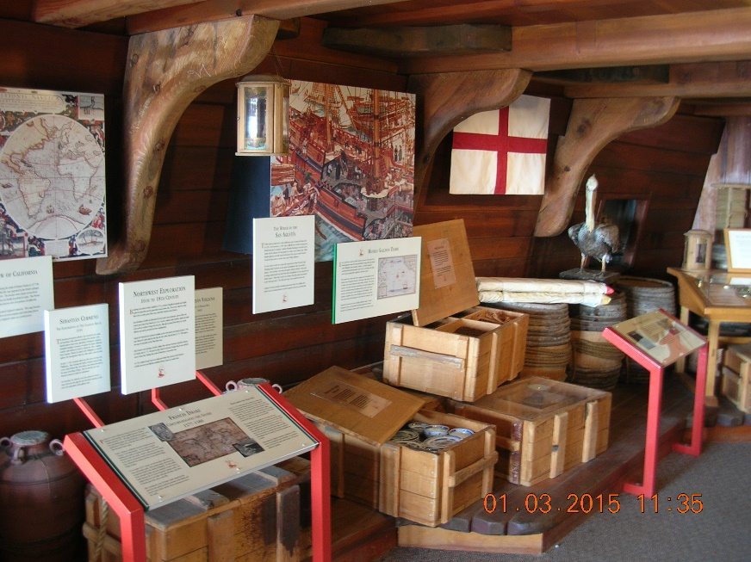
The Ken Patrick Visitor Center at Drake’s Beach has an exhibit on Drake and Soromenho. Check on the hours of this facility – they are often very limited.

Courtyard Display
11
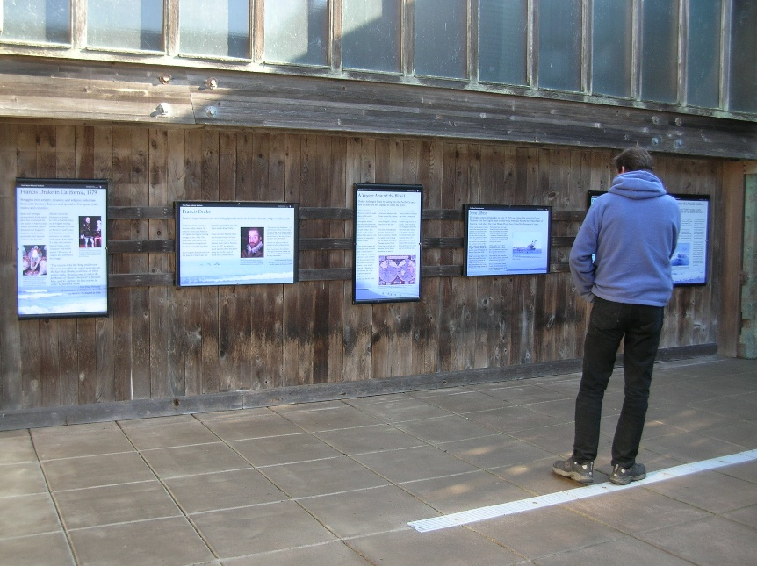
In the protected courtyard at the Ken Patrick Visitor Center are several interpretive panels explaining the 16th Century visits.

Plaque at the Lifeboat Station
B

The E Clampus Vitus Monument (1950)
12
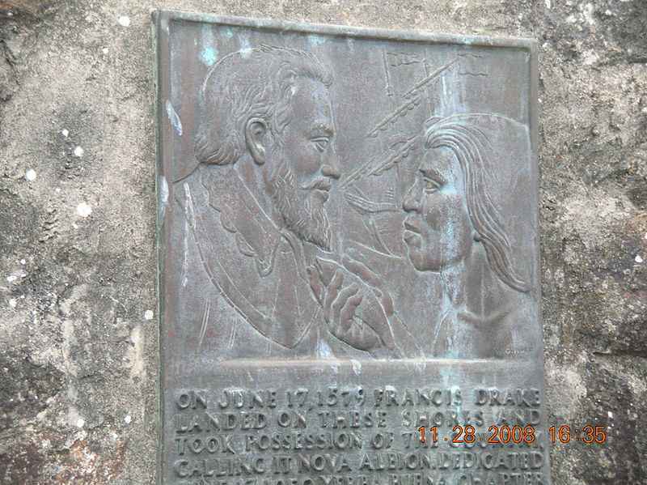
This monument is on the road to the Lifeboat Station.
E Clampus Vitus is a Gold Rush fraternal society which was recreated early in the 20th Century. Members put up plaques honoring California history. Drake has a high position in the lore of the club.
E Clampus Vitus members created one of the most-significant historical hoaxes in history when they planted a phony Plate of Brass. The real one is likely “still out there,” but it is probably made of lead, what the term “brass” meant in 1579.

Plaque at Limantour Beach Parking Lot
C

The Drakes Bay National Historic and Archaeological District Plaque
13
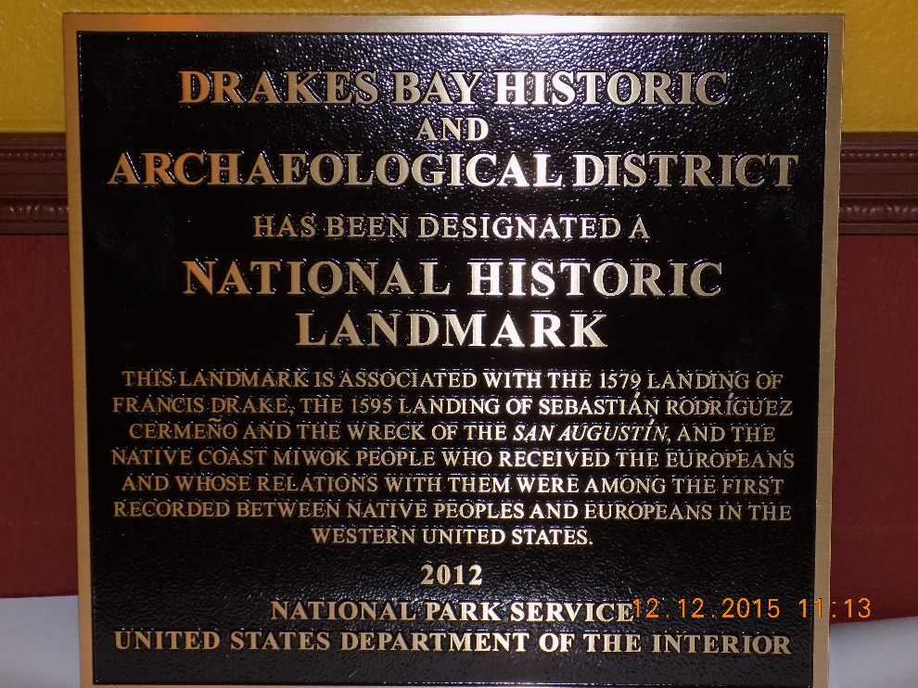
The Drakes Bay Historic and Archaeological District is the most important National Historic Landmark (NHL) to be designated since 1985.
This plaque was dedicated near the Limantour parking lot on October 22, 2016. From the parking lot, head toward the ocean. At the toilets, turn right, 100 yards down the Muddy Hollow Trail to find the plaque. The plaque may be relocated to a location near the parking lot in the coming months.

Sites at Bear Valley Visitor Center
14
D

Golden Hind Model
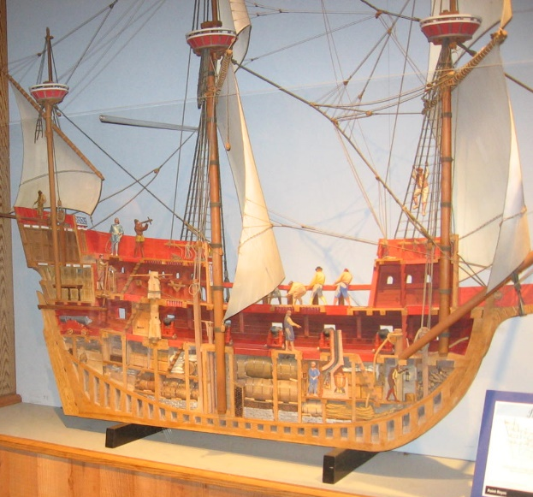
A large model of the Golden Hind is inside the theater at the Bear Valley Visitor Center. This model is about eight feet long and is the best representation of Drake’s ship. The model was built by noted historian Raymond Aker.

Visitor Center Exhibit
15
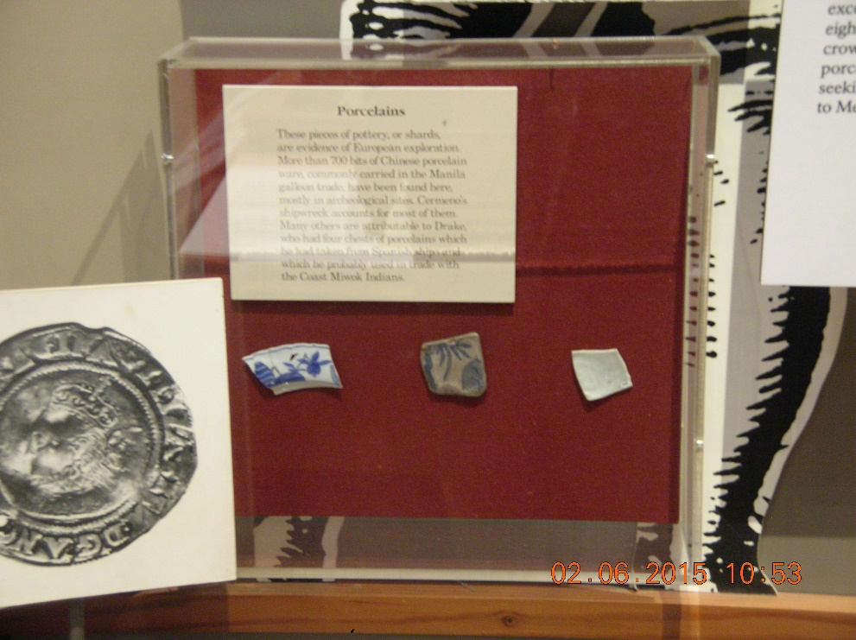
A small, inadequate exhibit shows a bit about the Drake and Soromenho visits. Of interest are the three pieces of porcelain. The one on the left was brought by Drake. The center and right shards came from Soromenho.

Park Dedication Plaque (1964)
16
Near the entrance to the Bear Valley Visitor Center is a plaque honoring First Lady, Lady Bird Johnson who dedicated the Point Reyes National Seashore in 1964. The Park was established to protect and provide public access to the important natural and historic features.
The actual ceremony with the First Lady was held at Drake’s Beach.

Kule Loklo
17
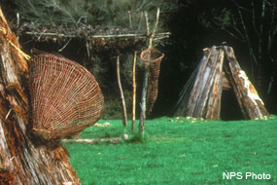
Working with local Coast Miwok, Kule Loklo was created as a model local Native American village site. It includes several traditional structures.
Toward the end of his visit at Drakes Bay, Drake made a trip into the interior of Marin County. Likely, he came near to the location of Kule Loklo.
Drake reported that the inland was far different from the coastal area. This area often has summer sunshine and warm temperatures in sharp contrast to the continuing fogs that plague the immediate coast.
The World Encompassed reported extensively on the Coast Miwok. The feathered baskets, attire, processions, ceremonies, tule balsa boats and more are described in the text.

Further Investigation
There are many stories beyond those few included here. For additional reading, see the following:
The World Encompassed by Sir Francis Drake (the navigator’s nephew)
Discovering Francis Drake’s California Harbor by Raymond Aker and Edward Von der Porten
Sir Francis Drake by John Sugden
The Cermeño Expedition at Drakes Bay – 1595 by Raymond Aker
Web searches including Wikipedia for the following will provide more details:
- New Albion
- The Drake Navigators Guild
- The Plate of Brass
- Sebastião Rodrigues Soromenho / Sebastián Rodríguez Cermeño
- Sir Francis Drake
- The Sir Francis Drake Society
- The Sir Francis Drake Association

